Design of Machine Elements
Third Edition

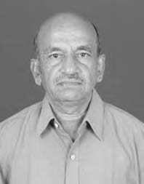
About the Author

V B Bhandari retired as Professor and Head, Department of Mechanical Engineering at Vishwakarma Institute of Technology, Pune. He holds First-Class BE and ME degrees in Mechanical Engineering from Pune University, and his teaching experience spans over 38 years in Government Colleges of Engineering at Pune, Karad and Aurangabad. He was also a postgraduate teacher of Pune University, Shivaji University and Marathwada University. Besides being a National Scholar, he has received five prizes from Pune University during his academic career.
Professor Bhandari was a member of ‘Board of Studies in Mechanical Engineering’ and a member of ‘Faculty of Engineering’ of Pune University.
He is a Fellow of Institution of Engineers (India), a Fellow of Institution of Mechanical Engineers (India) and a Senior Member of Computer Society of India. He was a Fellow of Institution of Production Engineers (India) and a Member of American Society of Mechanical Engineers (USA).
He has presented and published twenty technical papers in national and international conferences and journals, and is also the author of Introduction to Machine Design published by Tata McGraw Hill Education Private Limited.



Only two pages were converted.
Please Sign Up to convert the full document.

www.freepdfconvert.com/membership

